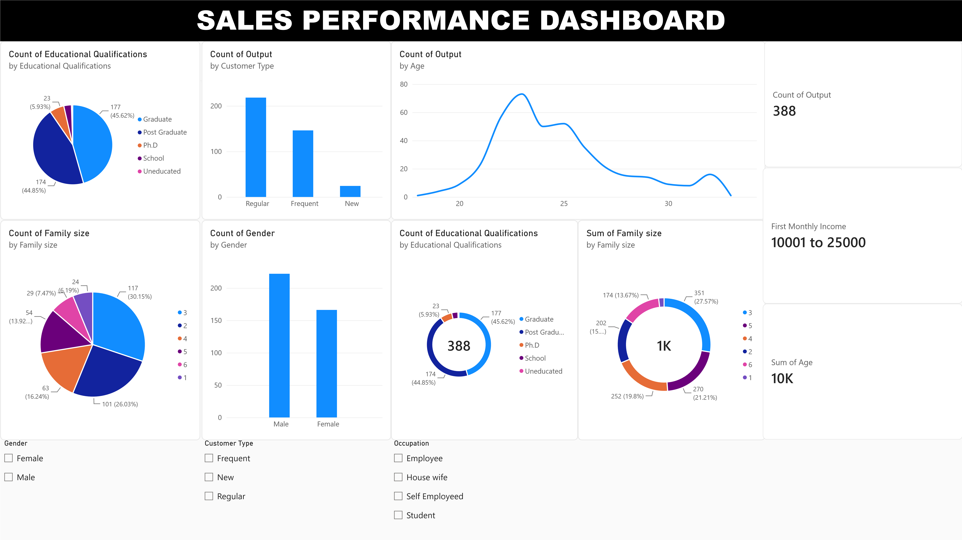
DASHBOARD INSIGHTS

1. Total Orders – The card shows the total number of orders recorded in the dataset and provides an overall view of customer activity.

2. Average Monthly Income – The average monthly income indicates the general income level of customers and helps understand their purchasing potential.

3. Average Customer Age – The average customer age represents the typical age of customers placing food-delivery orders.

4. Educational Qualification – Graduates and postgraduates make up a large portion of the customers, indicating that most customers have a higher level of education.

5. Family Size – Customers with smaller family sizes account for a significant portion of the orders, suggesting that food delivery is commonly used by small households.

6. Orders by Gender – The chart shows that male customers have more orders than female customers, indicating a higher share of orders from male customers.

7. Orders by Customer Type – The chart compares orders across different customer types and helps identify which customer group contributes the most orders.

8. Orders by Age – The line chart shows how the number of orders varies across different customer ages and helps identify the age groups with higher ordering activity.

9. Gender Slicer – The Gender slicer allows users to compare ordering patterns between male and female customers.

10. Customer Type Slicer – The Customer Type slicer allows users to focus on a specific customer group and analyze its ordering activity.

11. Occupation Slicer – The Occupation slicer allows users to analyze ordering patterns among customers from different occupations.

OVERALL INSIGHT – The dashboard shows that food-delivery orders vary according to customer demographics such as age, gender, education, family size, customer type, and occupation. These insights can help businesses understand their major customer groups and develop better marketing strategies.

